Healthy Eating

Games via Internet

 | 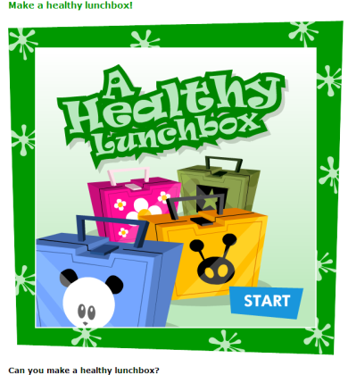 | A healthy Lunchbox  Drag and drop ingredients for a healthy lunchbox.  At the end your lunchbox will be checked to see if it is balanced.  Can print results.  http://www.foodafactoflife.org.uk/activity.aspx?siteId=5&sectionId=34&contentId=56
Make a balanced plate.
Drag and drop the foods as they appear
http://www.foodafactoflife.org.uk/activity.aspx?siteId=5&sectionId=34&contentId=55

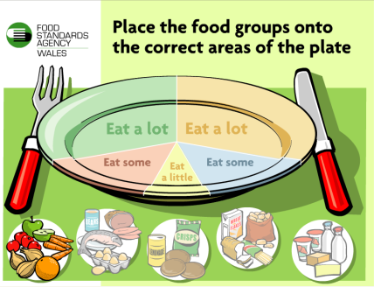 |  | Balance of Good Health Plate  Simple drag and drop the 5 food groups on to the plate  Do not be put off by the Welsh!  Click on Wales not Cymru.  http://www.glasgows.co.uk/fsa_interactives/PltLoad.swf
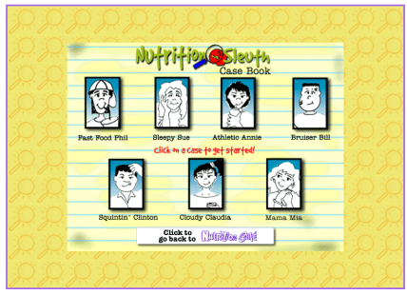 |  | Nutrition Sleuth  Hangman  Work out the missing nutrient  http://www.exhibits.pacsci.org/nutrition/nutrition_cafe.html
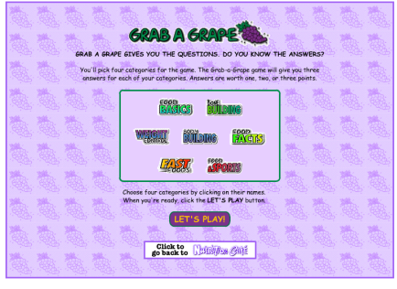 |  | Grab a Grape  Here is the answer, what is the question  http://www.exhibits.pacsci.org/nutrition/nutrition_cafe.html
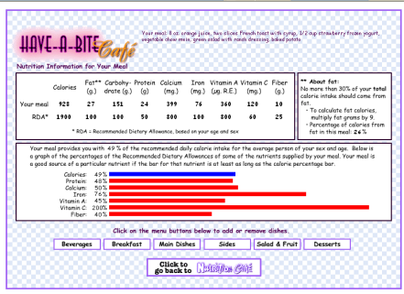 |  | Have a bite café.  Your meals for a day.  Are you eating right, choose a meal and find out.  http://www.exhibits.pacsci.org/nutrition/nutrition_cafe.html
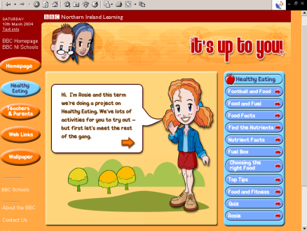 |  | Healthy Eating  Food and Fitness.  http://www.bbc.co.uk/northernireland/schools/4_11/uptoyou/index.shtml
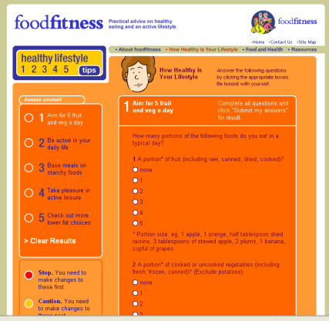 |  | Healthy Eating/Lifestyle Quiz  Best suited for one person to have a go.  http://www.foodfitness.org.uk/qu1.aspx
Banana Sportz

Chose the energy giving foods to win.

http://www.bananaland.com.au/games/banana-sportz/banana-sportz.php

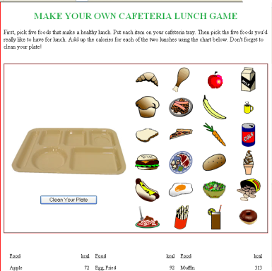 |  | Make your own Cafeteria Lunch Game  Select your lunch and work out your calories.  Try a healthy lunch versus an unhealthy one.  http://www.funnytummy.com/games/cafeteria-lunch.html
The Food Pyramid Game

Drag and drop

http://www.hooah4health.com/body/nutrition/pyramidinteractive.htm

Food Pyramid Sorter

Beat the clock as you sort the foods into the right place.

http://www.foodpyramidgames.com/games/ss_shockenglish.htm

Match the Food Groups

Drag and drop

http://www.dairycouncilofca.org/activities/pyra_main.htm

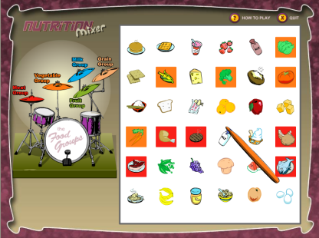 |  | Nutrition Mixer – Food Groups  Work out the food groups.  http://www.nutritionexplorations.org/kids/activities/arianna.asp
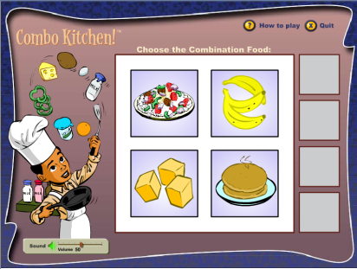 |  | Combo Kitchen  Work out the food combinations  http://www.nutritionexplorations.org/swfs/kids-games/arianna/games/combokitchen/combokitchen.html
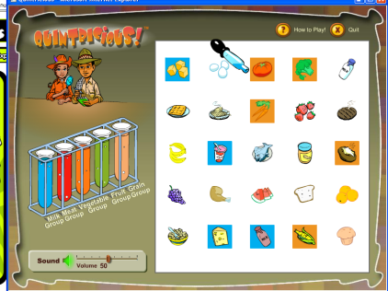 |  | Quintricious  The 5 Food Groups  Tetris style game  http://www.nutritionexplorations.org/swfs/kids-games/arianna/games/quintricious/quintricious.html
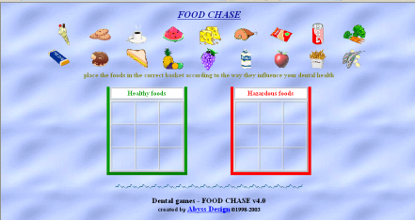 |  | Dental Health  Sort the food out by healthy or hazardous for your teeth.  http://users.forthnet.gr/ath/abyss/games/food.htm
Multi choice answers about healthy eating and potatoes
http://www.potatoesforschools.org.uk/FFT/HK/index.html

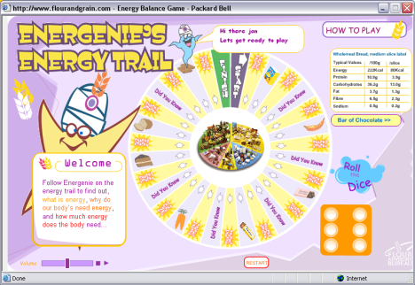 |  | The Energenie Energy Trail  Age 7-11 year olds  http://www.flourandgrain.com/gamesandvideos.asp
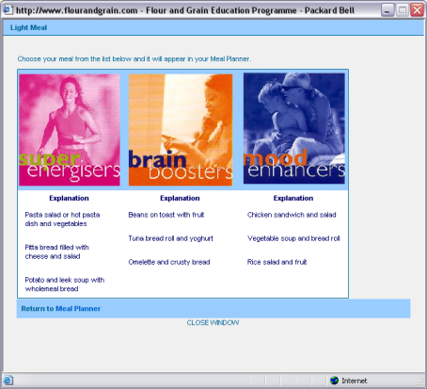 |  | Healthly Living Meal Planner  Age 11-14 year olds  (Suitable for individuals, not a game).  Try out the Interactive Meal Planner to see if you can design a balanced diet for a week, or find extra info by printing the Investigating Good Meal Planning activity sheet.  http://www.flourandgrain.com/gamesandvideos.asp
The Picnic Panic Game

Catch the healthy food in the picnic basket.

http://www.kidsfoodclub.org/fun/picnic.asp

